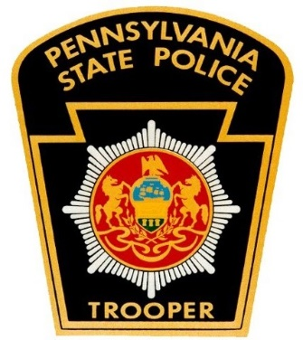

PENNSYLVANIA STATE POLICE
Troop H, Carlisle

PSP Carlisle is sponsoring a FREE car seat event for interested families with young children who qualify for car seat needs.

WHERE: Westminster Drive parking lot
(Outside Target)
WHEN: September 20, 2020
TIME: 10:00 AM to 6:00 PM
WHY: The safety of our children is always paramount, and this allows us to provide instructional knowledge to parents during National Child Passenger Safety Week.

Contact PSP Carlisle at 717-249-2121 for more information

